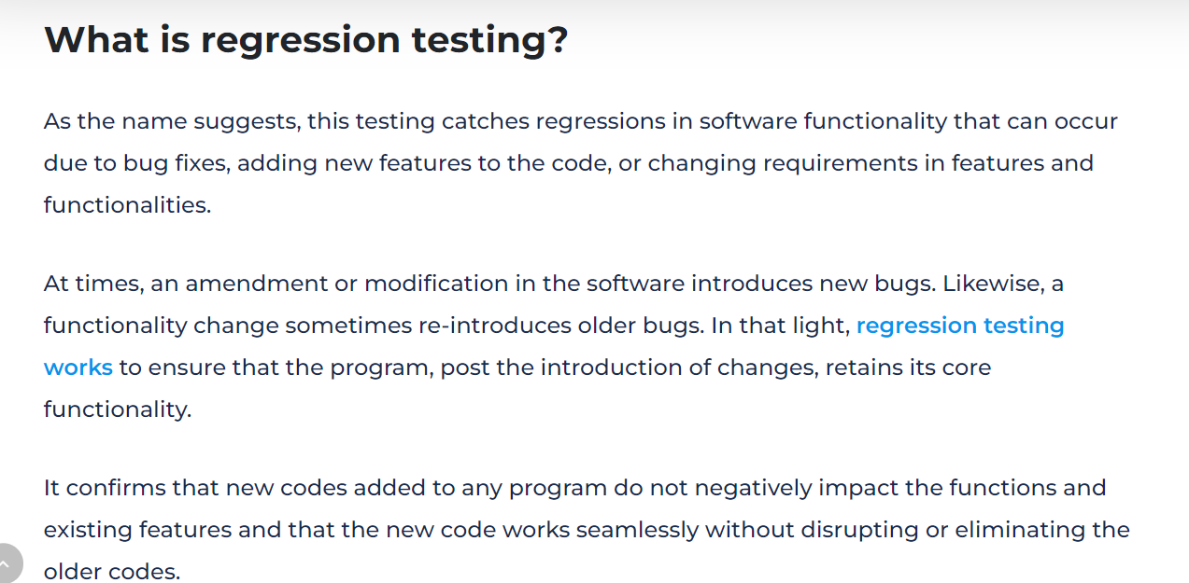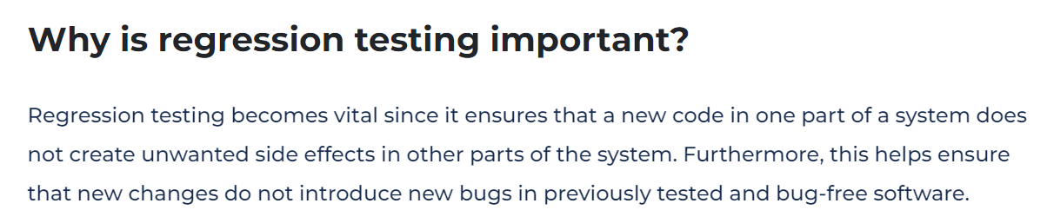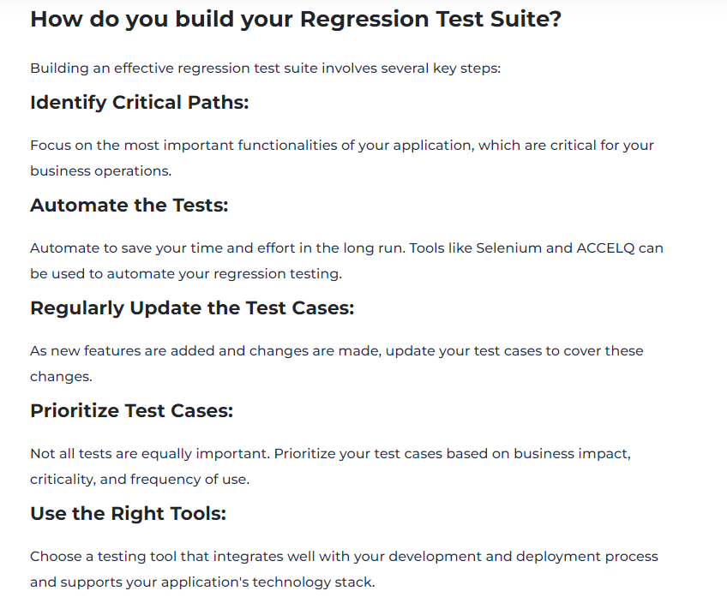

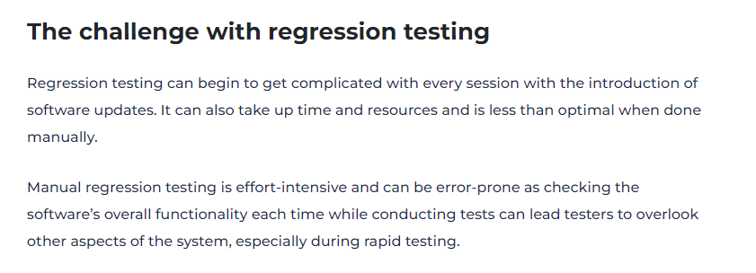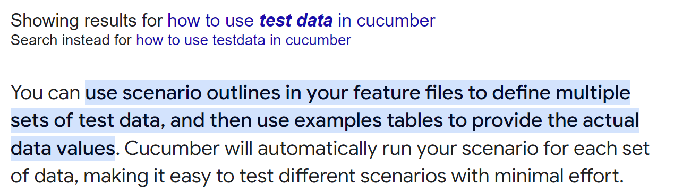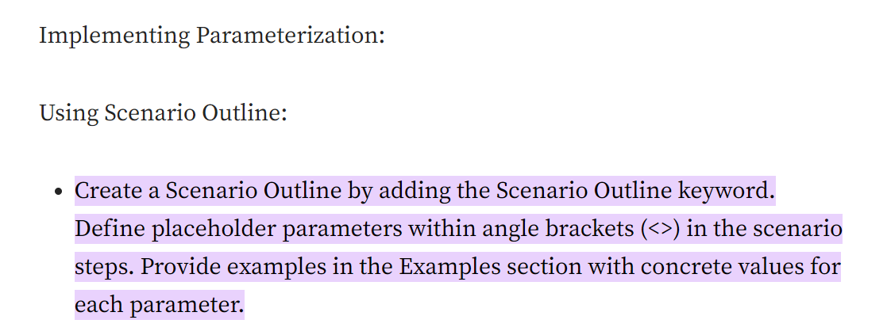

How to take screenshot?

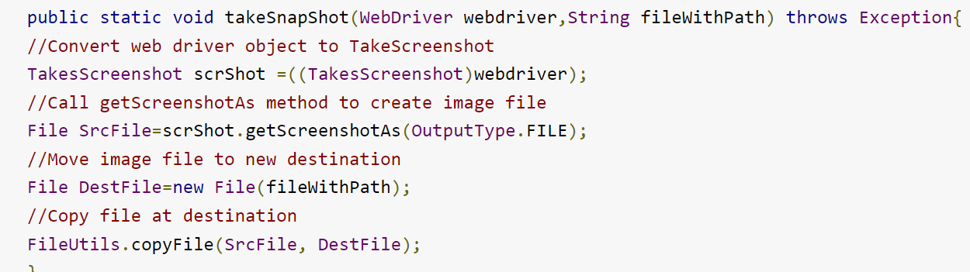

## Type casting

Convert a value from one data type to another data type is known as **type casting**.

## Types of Type Casting

There are two types of type casting:

* Widening Type Casting
* Narrowing Type Casting

### Widening Type Casting

Converting a lower data type into a higher one is called **widening** type casting. It is also known as **implicit conversion** or **casting down**. It is done automatically. It is safe because there is no chance to lose data. It takes place when:

* Both data types must be compatible with each other.
* The target type must be larger than the source type.

1. **byte** -> **short** -> **char** -> **int** -> **long** -> **float** -> **double**

For example, the conversion between numeric data type to char or Boolean is not done automatically. Also, the char and Boolean data types are not compatible with each other. Let's see an example.